Collections Internal Working
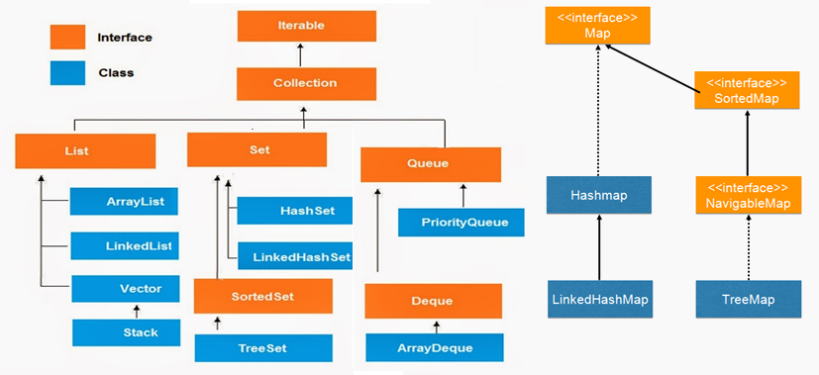
Iterator interface : provides the facility of iterating the elements in forward direction only.
1 | public boolean hasNext() | It returns true if iterator has more elements.
2 | public Object next() | It returns the element and moves the cursor pointer to the next element.
3 | public void remove() | It removes the last elements returned by the iterator. It is rarely used.

Collection : Root interface with basic methods like add(), remove(), contains(), isEmpty(),etc 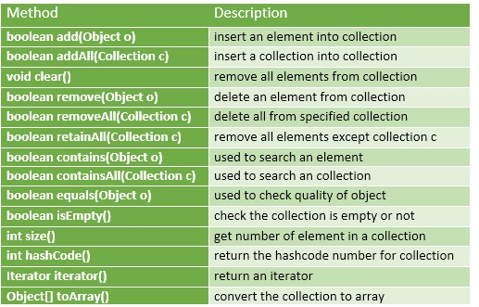
If you see above only add, remove methods are their. get() is not their. Getting methods are implemented based on underlying data Structure . And add(Object) method is Object based, not index. Because these are generalized methods which will apply for all collection classes

List
- List is child interface of collection
- If we want to represent group of individual objects as a single entity where duplicates are allowed & insertion order must be preserved then we should go for List
- We can preserve insertion order via index & differentiate duplicate objects using index
- Index will play very important role in List
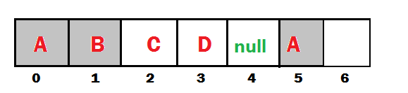
Add / Remove | Find | Special
Boolean add(int index, Object o)  Boolean addAll(int index,Collection c)  Boolean remove(int index) | Object get(int index)  Object set(int Object new)  Int indexOf(Object c)  Int lastIndexOf(Object c) | ListIterator listIterator()

ArrayList – Internal implementation
- The underlying data structure is ResizableArray or Growable Array
- Duplicates are allowed
- Insertion order is preserved
- Heterogeneous(different datatypes) Objects are allowed
- Null is insertion is allowed
- ArrayList implements Serializable, Clonable & RandomAccess
- Except TreeSet & TreeMap Everywhere Heterogeneous Objects are allowed
Internal implementation : http://www.codenuclear.com/how-arraylist-works-internally-java/
1.ArrayList grows dynamically as the elements are added to it. Internally an ArrayList uses an Object[] Array.
private transient Object[] elementData;
2.When an object of ArrayList is created without initial capacity, the default constructor of the ArrayList class is invoked. default capacity of 10 is assigned at a time of empty initialization of ArrayList.
public ArrayList() {
this(10);
}
3. In the add(Object), the capacity of the ArrayList will be checked before adding a new element
public boolean add(E e) {
ensureCapacity(size + 1); // Increments modCount!!
elementData[size++] = e;
return true;
}
public void ensureCapacity(int minCapacity) {

if (minCapacity > oldCapacity) {
int newCapacity = (oldCapacity * 3) / 2 + 1;
elementData = Arrays.copyOf(elementData, newCapacity);
}
}
4. If size of the filled elements is greater than the maximum size of the array then increase the size of array by using below formulae, Then elements will copy to old Array to New Array
Till Java 6 : int newCapacity = (oldCapacity * 3)/2 + 1;
From Java 7 : int newCapacity = oldCapacity + (oldCapacity >> 1); (50% of old)
5.If elements are adding in the middle index, ArrayElements will shifted to Right
  - Adding not good o(n)
  - Get(by index) Good o(1)

Interviewer : What is the runtime performance of the get() method in ArrayList , where n represents the number of elements ?
get() ,set() , size() operations run in constant time i.e O(1)
add() operation runs in amortized constant time , i.e adding n elements require O(n) time.

public class ArrayListDemo {
public static void main(String[] args) {
/*1.ArrayList With Defalut Capacity 10 is created
* & assiged values as null
* elemetntdata = [null, null, null,....10 Objects]
* modcount = 0, no modifications performed
* size=0
* */
ArrayList<String> list = new ArrayList<>();

/*adding first element, add("one");
* elementdata=["one,null, null, null ....."]
* modcount = 1
* Size = 1 *
* */
list.add("One");
list.add("Two");
list.add("Three");
System.out.println(list);
}
}
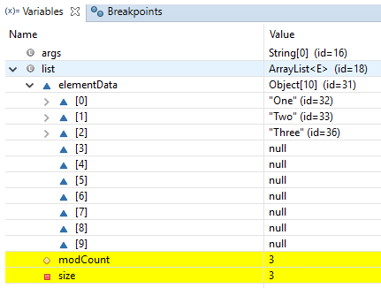
- Usually we use collections to hold & transfer objects from one location to another location. To provide support for this requirement every collection class implements Serializable & Clonable interfaces
- ArrayList and Vector classes implements RandomAccess interface, so that any random element we can access with same speed. RandomAccess is a marker interface & doesn’t have any methods
- Insertion/Deletion is middle ArrayList is the Worst choice. For retrieval Best Choice
- In every collection class toString() is overridden to print data readable format [ob1, ob2, ob3]

LinkedList– Internal implementation
- Underlying data structure is DoubleLinkedList
- Insertion order is preserved
- Duplicates are allowed
- Heterogeneous objects are allowed
- Null insertion is allowed
- LinkedList implements Serializable & Clonable interfaces but not RandomAccess
- Best Choice for Insertion/Deletion, Worst for Retrieval operation
void addFirst(Object o)  void addLast(Object o) | Object getFirst()  Object getLast() | Object removeFirst()  Object removeLast()

Implementation
1.LinkedList class in Java implements List and Deque interfaces and LinkedList implements it using Doubly LinkedList
2.In the implementation of the LinkedList class in Java there is a private class Node which provides the structure for a node in a doubly linked list. It has “item” variable for holding the value and two reference to Node class itself for connecting to next and previous nodes.
private static class Node<E> {
E item;
Node<E> next;
Node<E> prev;
Node(Node<E> prev, E element, Node<E> next) {
this.item = element;
this.next = next;
this.prev = prev;
}
}
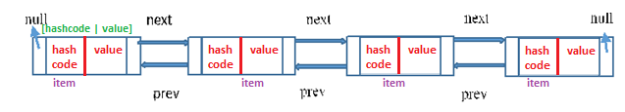
3.Reference To Previous Element of first node and Reference To Next Element of last node are null as there will be no elements before the first node and after the last node
4. You can insert the elements at both the ends and also in the middle of the LinkedList. Below is the list of methods for insertion operations.
5.If you call the regular add() method or addLast() method internally linkLast() method is called
/** * Links e as last element. */
void linkLast(E e) {
final Node<E> l = last;
final Node<E> newNode = new Node<>(l, e, null);
last = newNode;
if (l == null)
first = newNode;
else
l.next = newNode;
size++;
modCount++;
}

6.If you call addFirst() method internally linkFirst() method is called.
private void linkFirst(E e) {
final Node<E> f = first;
final Node<E> newNode = new Node<>(null, e, f);
first = newNode;
if (f == null)
last = newNode;
else
f.prev = newNode;
size++;
modCount++;
}

5.Insertion and removal operations in LinkedList are faster than the ArrayList. Because in LinkedList, there is no need to shift the elements after each insertion and removal, because we only add elements at First or Last no in-between . only references of next and previous elements need to be changed.
6.Retrieval of the elements is very slow in LinkedList as compared to ArrayList. Because in LinkedList, you should traverse from beginning or end (whichever is closer to the element) to reach the element.
public class LinkedListDemo {
public static void main(String[] args) {

LinkedList<String> list = new LinkedList<>();
list.add("One");
list.add("Two");
list.add("Three");
System.out.println(list);
}
}
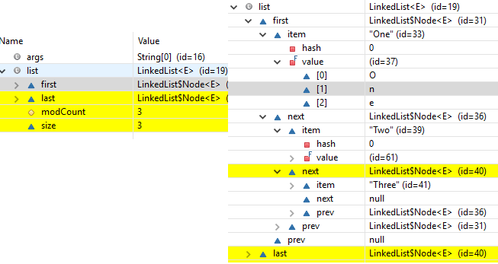

Vector– Internal implementation(Same as ArrayList)
- The underlying data structure is ResizableArray or Growable Array
- Duplicates are allowed
- Insertion order is preserved
- Heterogeneous(different datatypes) Objects are allowed
- Null is insertion is allowed
- Vector implements Serializable, Clonable & RandomAccess
- Vector is Synchronized
Add / Remove | Find | Special
addElement(Obejct o)  removeElement(Object o)  removeElementAt(int index)  removeAllElements() | Object elementAt(int index)  Object firstElement()  Object lastElemet() | Int size()  Int capacity()//to know default/incremental capacity  Enumeration elements()
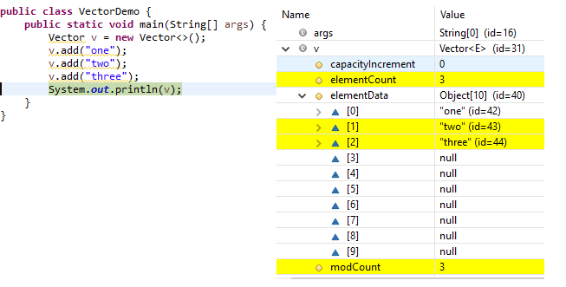

Stack– Internal implementation
The Stack class represents a last-in-first-out (LIFO) stack of objects. It extends class Vector with five operations(below 5 methods) that allow a vector to be treated as a stack
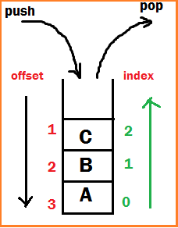
Object push(Object o) -Insert an object into top of the stack
Object pop() -Removes & returns from top of the stack
Object peak() -Just returns Object from top of the stack
boolean empty() -returns TRUE if stack is empty
int search(Object o) – returns offset if available otherwise -1

- Adding item in Stack is called PUSH.
- Removing item from stack is called POP.
- Push and pop operations happen at Top of stack.
- Stack follows LIFO (Last in first out) - means last added element is removed first from stack
- Push - O(1) [as we push element at Top of Stack in java]
- Pop - O(1) [as popping is also done at Top of Stack in java]
Uses Growable array, initial capacity as 10, same as ArrayList
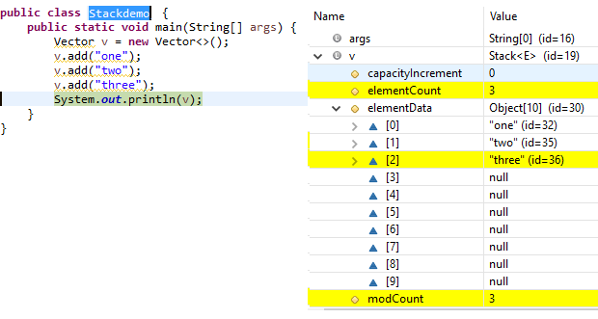

Map
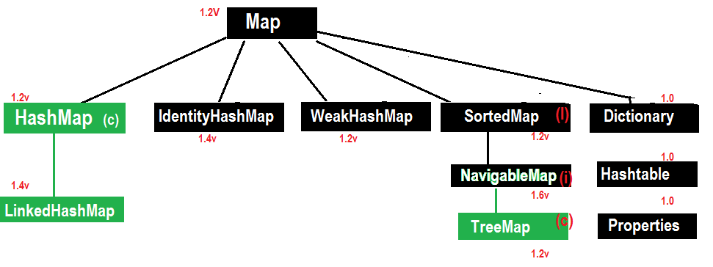
- Object put(Object Key, Object value) – To add one <key, value> pair to the Map.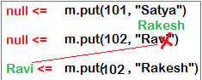
if the <key> is already present then oldvalue will be replaced with new Value & returns old value.
- Object putAll(Map m)
- Void putAll(Map m)
- Object get(Object key)
- Object remove(Obejct key)
- boolean containsKey(Object Key)
- boolean containsValue(Object value)
- boolean isEmpty()
- int size()
- void clear

HashMap – Internal implementation (HashTable)
- The underlying datastructure is Hashtable+LinkedList
- Insertion order is not preserved & it is based on Hashcode of <Keys>
- Duplicate keys are NOT allowed, but values can be duplicated.
- Hetrogenious objects are allowed for both Key & Value
- null is allowed for key(only once)
- null is allowed for Values(any no. of times)
- HashMap implemets sericalizable & Clonable inferfaces but not RandomAccess
- HashMap is the best choice for Seraching opertions

Constructors
- HashMap h = new HashMap () //16 capacity, Def. fill ratio = 0.75
Creates an empty Object with def. initial capacity 16 & def. fill ratio 0.75
- HashMap h = new HashMap (int intialcapacity) // Def. fill ratio = 0.75
- HashMap h = new HashMap (int intialcapacity, float fillRatio)
- HashMap h = new HashMap (Map m)
Internal implementation: http://www.thejavageek.com/2016/03/12/working-of-hashmap-in-java/
- Initial Capacity(16): This is the capacity of hashmap to store number of key value pairs
- Load Factor/Fill ratio(0.75): A parameter responsible to determine when to increase size of hashmap
- Threshold value(cap*0.75=12): When number of key value pairs is more than threshold value, then hashmap is resized.
public class HashMapDemo {
public static void main(String[] args) {
HashMap<String, String> map = new HashMap<>();

map.put("one", "AAA");
map.put("two", "BBB");
map.put("three", "CCC");
map.put("four", "DDD");
System.out.println(map);
}
}
{ four=DDD, one=AAA, two=ZZZ, three=CCC} //insertion ordered not preserved

1.On this code it will creates the HashMap object with,
HashMap<String, String> map = new HashMap<>();
- Default Bucket size is 16 , with Entry table[] of 16 buckets
- loadfactor as 0.75
- initializes with null values
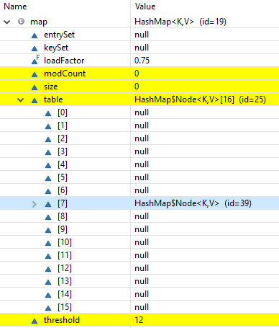
2.Each entry into HashMap is an Entry Object, which contains [hashcode, key, value, next] data fields.
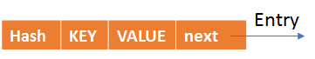
static class Entry<K,V> implements Map.Entry<K,V> {
final int hash;
final K key;
V value;
Entry<K,V> next;
}

put() method
Now we are ready, by adding map.put("one", "AAA"); following actions will be performed
public V put(K key, V value)
{
if (key == null)
return putForNullKey(value); hascode =0, bucketlocation =0
int hash = hash(key.hashCode()); Gets hashcode
int i = indexFor(hash, table.length); Gets Bucket location
for (Entry<K,V> e = table[i]; e != null; e = e.next)
{
Object k;
if (e.hash == hash && ((k = e.key) == key || key.equals(k)))
{
V oldValue = e.value;
e.value = value;
e.recordAccess(this);
return oldValue;
}
}
modCount++;
addEntry(hash, key, value, i);
return null;
}

1.Using hashcode() method
- First, it checks for the if the key given is null or not, if the given key is null it will be stored in the ‘0’th position as the hashcode of null will be 0(hashcode=0), & if not null gets the hashcode of the Key
static final int hash(Object key) {
int h;
return (key == null) ? 0 : (h = key.hashCode()) ^ (h >>> 16);
}

- Now indexFor(hash, table.length) function is called to calculate exact index(Bucekt) position for storing the Entry object. It’ s like Bucket = hashcode % tablecapacity, for the above code bkt = 110183%15 = 8(7th bucket)
2.Using equals() method
- Now it compares the current key value with existed key values by newkey.equals(oldkey) method, if found it just updates the value & if not found it will create the new node by addEntry(hash, key, value, i);and add it to the calculated Bucket location(7)
Get() method
we already know how Entry objects are stored in a bucket and what happens in the case of Hash Collision it is easy to understand what happens when key object is passed in the get() method of the HashMap to retrieve a value.
Using the key (passed in the get() method) again hash value will be calculated to determine the bucket where that Entry object is stored, in case there are more than one Entry object with in the same bucket (stored as a linked-list) equals() method will be used to find out the correct key. As soon as the matching key is found get() method will return the value object stored in the Entry object
public V get(Object key)
{
if (key == null)
return getForNullKey();
int hash = hash(key.hashCode());
for (Entry<K,V> e = table[indexFor(hash, table.length)];e != null;e = e.next)
{
Object k;
if (e.hash == hash && ((k = e.key) == key || key.equals(k)))
return e.value;
}
return null;
}
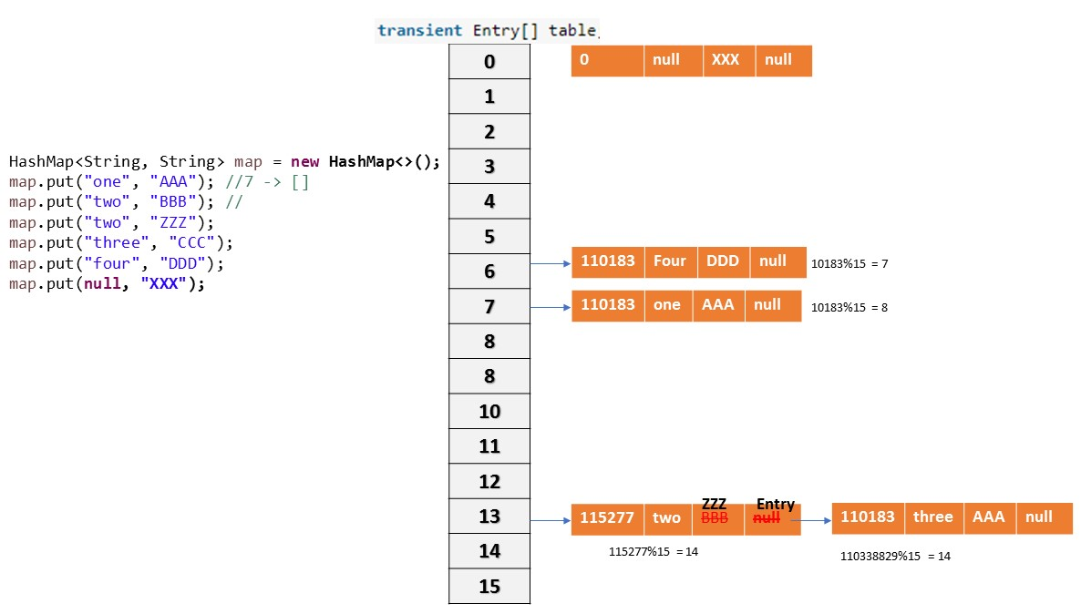
Collision
If two key objects are returns same hashcode, then which object should insert at a given Bucket is known as “Collision”. So, in case of collision, Entry objects are stored in LinkedList form. The address of the next element will be stored in previous element.

Rehashing
- When the number of items in map, crosses the Load factor limit at that time hashmap doubles its capacity and hashcode is re-calculated of already stored elements for even distribution of key-value pairs across new buckets.
- So for each existing key-value pairs, hashcode is calculated again with increased hashmap capacity as a parameter, which results in either placing the item in same bucket or in different bucket.
- Rehashing is done to distribute items across the new length hashmap, so that get and put operation time complexity remains O(1).
- Hashmap maintain complexity of O(1) while inserting data in and getting data from hashmap, but for 13th key-value pair, put request will no longer be O(1), because as soon as map will realize that 13th element came in, that is 75% of map is filled.
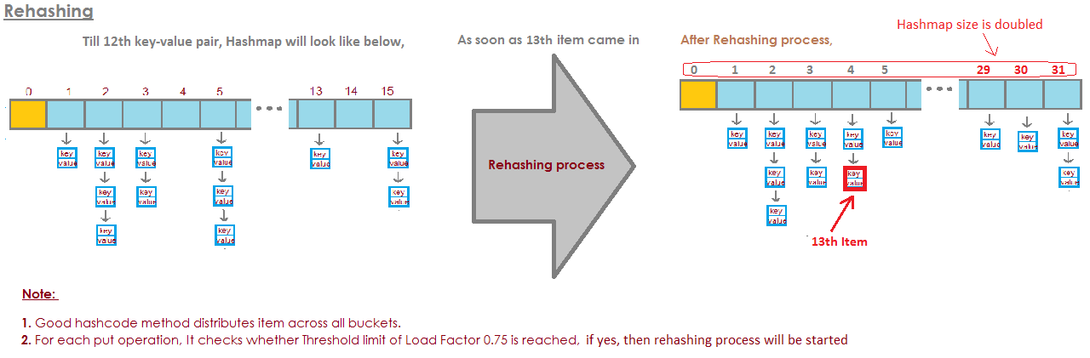
Points to note -
- HashMap works on the principal of hashing.
- HashMap uses the hashCode() method to calculate a hash value. Hash value is calculated using the key object. This hash value is used to find the correct bucket where Entry object will be stored.
- HashMap uses the equals() method to find the correct key whose value is to be retrieved in case of get() and to find if that key already exists or not in case of put().
- Hashing collision means more than one key having the same hash value, in that case Entry objects are stored as a linked-list with in a same bucket.
- With in a bucket values are stored as Entry objects which contain both key and value.
- In Java 8 hash elements use balanced trees instead of linked lists after a certain threshold is reached while storing values. This improves the worst case performance from O(n) to O(log n).
Improvements in Java 8
- There is a performance improvement for HashMap objects where there are lots of collisions in the keys by using balanced trees rather than linked lists to store map entries
- The principal idea is that once the number of items in a hash bucket grows beyond a certain threshold, that bucket will switch from using a linked list of entries to a balanced tree. In the case of high hash collisions, this will improve worst-case performance from O(n) to O(log n).

LinkedHashMap – Internal implementation
- LinkedHashMap is just an extension of HashMap , internally uses HashTable+DoublyLinkedList
- It has two references head and tail which will keep track of the latest object inserted and the first object inserted
1.Each node in a LinkedHashMap needs to have information about previous node and next node as the order in which they are accessed in important. The structure is as follows.
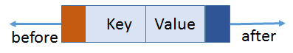
class Entry<K,V> extends HashMap.Node<K,V> {
Entry<K,V> before, after;
Entry(int hash, K key, V value, Node<K,V> next) {
super(hash, key, value, next);
}

2.After inserting map.put("one", "AAA");,Bucket with 16 capacity is created, hashcode & index will be caluculated.Here one is added, head and tail will refer to it.
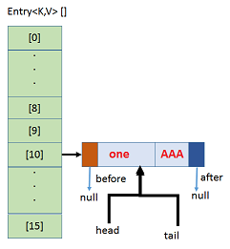
3.On adding map.put("two", "BBB");, inserted in 8th bucket & it is next to “one”, so head one, tail two, before & after will linked, like this all elements will be added & Insertion order will be marinated.
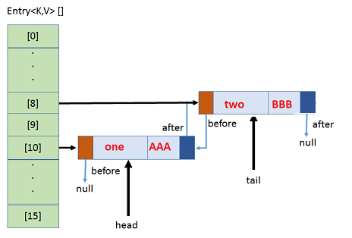
4.If any collision, new element will be added in same Bucket location with LinkedList& points to next.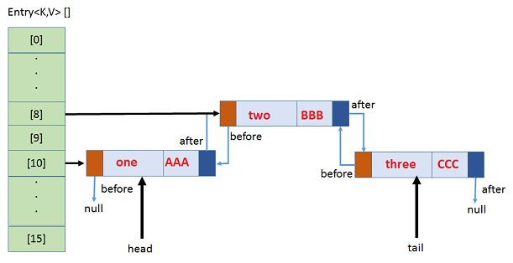

public class HashMapDemo {

public static void main(String[] args) {
LinkedHashMap<String, String> map = new LinkedHashMap<>();
map.put("one", "AAA"); //7 -> []
map.put("two", "BBB"); //
map.put("two", "ZZZ");
map.put("three", "CCC");
map.put("four", "DDD");
map.put(null, "XXX");
System.out.println(map);
}
}
{one=AAA, two=ZZZ, three=CCC, four=DDD, null=XXX}
So here Insertion Order is preserved, elements the order they added, same order they will store

TreeMap – Internal implementation
- Underlying D.S is RED-BLACK TREE
- Insertion order is NOT preserved & it is based on some sorting order of KEYS
- DUPLICATE keys are NOT allowed, but values can be duplicated
- If we are depending on default natural sorting Order then KEYS should be Homogeneous & Comparable otherwise we will get Runtime exception saying ClassCastException
- If we are defining our own sorting by comparator then KEYS should need not be Homogeneous & Comparable. We can take Heterogeneous & non- comparable Objects also.

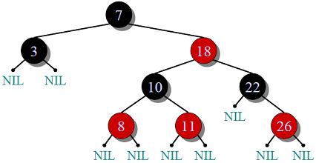
Red-Black Tree
- Every node has a color either red or black.
- Root of tree is always black.
- There are no two adjacent red nodes (A red node cannot have a red parent or red child).
- Every path from root to a NULL node has same number of black nodes.

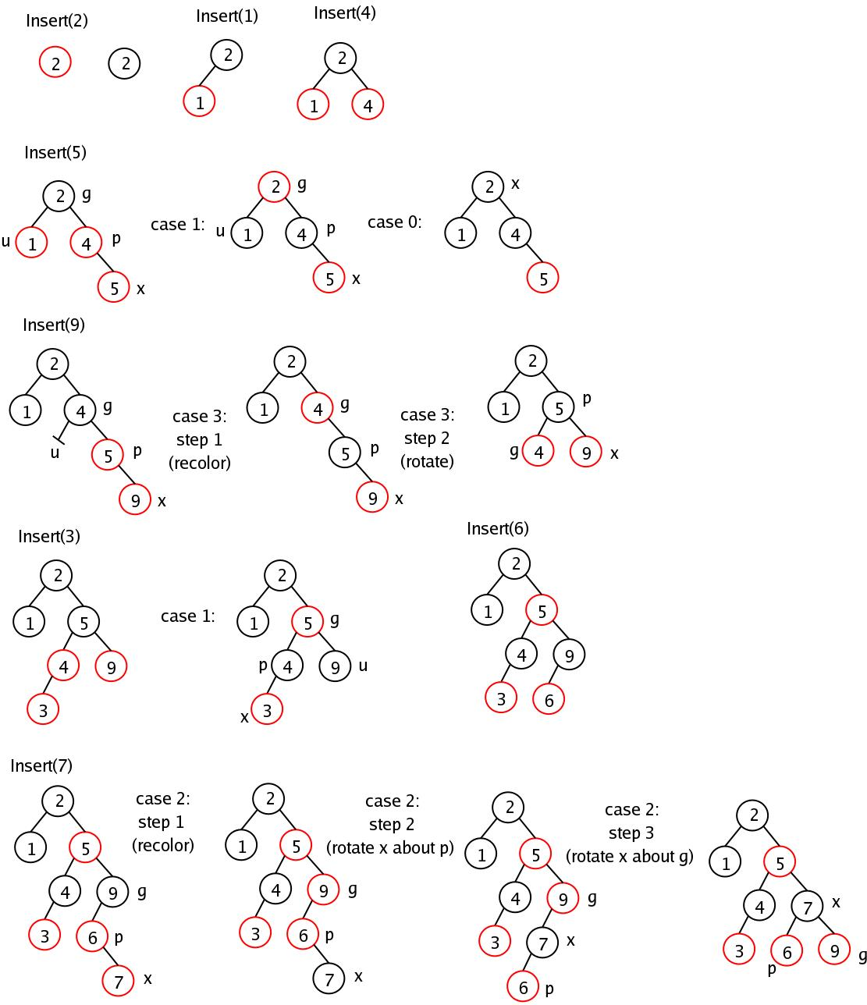
Constructors
TreeMap h = new TreeMap () //Default. SortingOrder
Creates an Empty TreeMap Object, all the elements inserted in Default Natural SortingOrder
TreeMap h = new TreeMap (Comparator c) //Customized. SortingOrder
Creates an Empty TreeMap Object, all the elements inserted in Customized Natural SortingOrder
TreeMap h = new TreeMap (Map c)
TreeMap h = new TreeMap (SortedMap s)
Implementation
1.TreeMap is based on tree data structure. Each node in tree will have three references parent(key,value), right and left element.
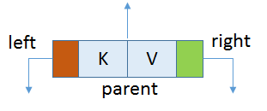
- The left element will always be logically less than parent element.
- The right element will always be logically greater than OR equal to parent element
static final class Entry<K,V> implements Map.Entry<K,V> {
Entry<K,V> left;
Entry<K,V> right;
Entry<K,V> parent;
K key;
V value;
}

2. Comparison of Objects is done by natural order i.e. those object who implement Comparable interface and override compareTo(Object obj) method. Based on the return value,
- If obj1.compareTo(obj2) , if obj<obj2 then returns negative number
- If obj1.compareTo(obj2), if obj>obj2 then returns positive number
- If obj1.compareTo(obj2) , if obj==obj2 then returns zero
3.When we use put(K,V) method it checks if root is pointing anywhere if no it makes the instance of Entry<K,V> and point to root;
4.The constructor of Entry<K,V> takes key, value and parent. In this case parent is null;
5.For the next time we enter using put(K,V) it first identifies the comparison mechanism to use.
6.First it check the Comparator class is present or not . This class is passed when creating the instance of TreeMap. If not present it uses the Key's Comparable implementation.
7.It then traverse through root and compares each node with the node entered and depending upon the comparison places the node either left or right of the parent node.
treeMap.put(1, "one"); //1
there are no elements in it. So 1 is the first object being inserted as key. This is treated as root node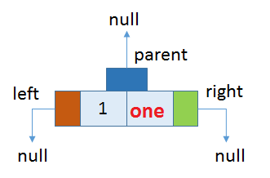

treeMap.put(5, "five"); //2
Now, 5 is logically greater than 1 and hence according to our rules,
- 5 will be placed to the right of 1.
- 1 will be parent of 5.
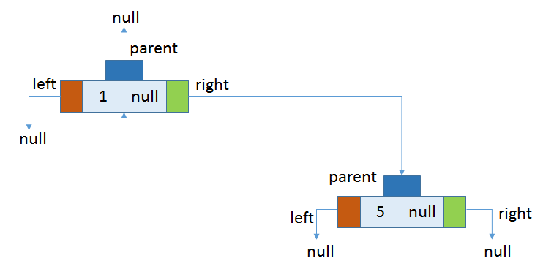
treeMap.put(3, "three"); //3
treeMap.put(2, "two"); //4
treeMap.put(4, "four"); //5, after inserting all these final strucre will be
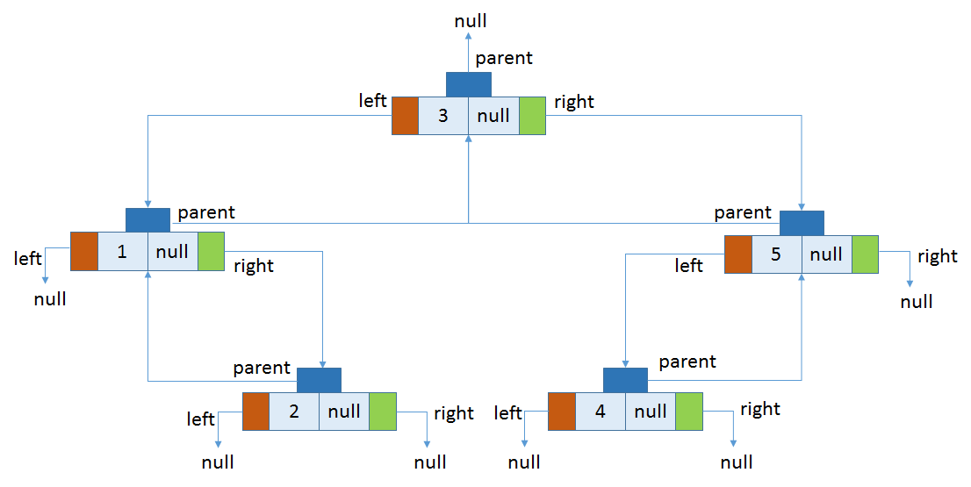
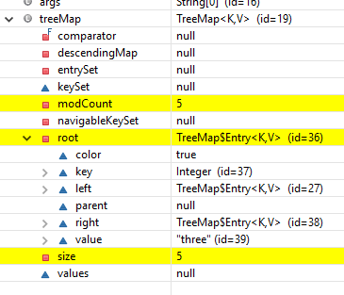

Set
- Set is child interface of collection
- If we want to represent group of individual objects as a single entity where duplicates are Not allowed & insertion order Not be preserved then we should go for List
- Set Interface doesn’t contain any new method & we have to use only collection interface methods.
- In All Hash related collections insertion is based on Hashcode.so no insertion order preserved.

HashSet – Internal implementation
- The underlying datastructure is Hashtable, internally uses HashMap
- Duplicate Objects are Not Allowed
- Insertion Order is Not preserved & it is based hash code of Objects
- Null Insertion is possible(Only once), Heterogeneous Objects are allowed
- Implements Serializable & Clonable but not RandomAccess Interface
- HashSet is the Best Choice for Search Operation
- In HashSet Duplicates are not allowed. If we are trying to insert duplicates then it won’t get any Compile time or Runtime Error and add() method simply returns FALSE
Constructors
HashSet h = new HashSet () //16 capacity, Def. fill ratio = 0.75
Creates an empty Object with def. initial capacity 16 & def. fill ratio 0.75
HashSet h = new HashSet (int intialcapacity) // Def. fill ratio = 0.75
HashSet h = new HashSet (int intialcapacity, float fillRatio)
HashSet h = new HashSet (Collection c)
Implementation
1.HashSet uses HashMap internally to store it’s objects. Whenever you create a HashSet object, one HashMap object associated with it is also created.
public HashSet()
{
map = new HashMap<>(); //Creating internally backing HashMap object
}
public HashSet(int initialCapacity, float loadFactor)
{
map = new HashMap<>(initialCapacity, loadFactor);
}

2.The elements you add into HashSet are stored as keys of this HashMap object. The value associated with those keys will be a constant(PRESENT).
Add Method
- add() method of HashSet class internally calls put() method of backing HashMap object by passing the element you have specified as a key and constant “PRESENT” as it’s value.
private static final Object PRESENT = new Object();
public boolean add(E e)
{
return map.put(e, PRESENT)==null;
}
- In Hash Map , hash function is calculated using key but in HashSet value itself to calculate the hash function.
- Since hash function is calculated using value that is why only unique values are stored in the HashSet.
- When element is added to HashSet using add(E e) method internally HashSet calls put() method of the HashMap where the value passed in the add method becomes key in the put() method. A dummy value “PRESENT” is passed as value in the put() method.
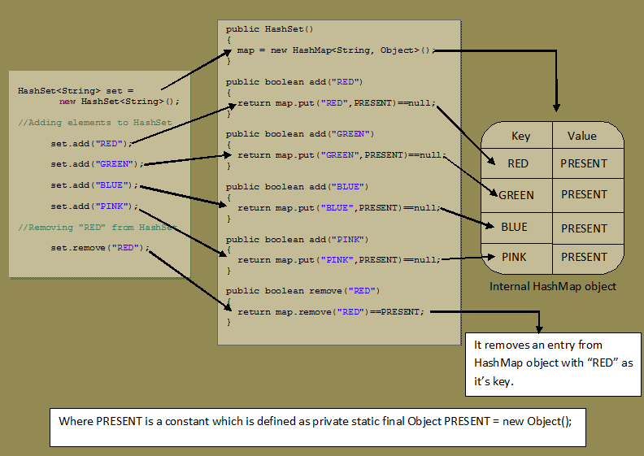

LinkedHashSet – Internal implementation
- LinkedHashSet is an extended version of HashSet. HashSet doesn’t follow any order where as LinkedHashSet maintains insertion order
- HashSet uses HashMap object internally to store it’s elements where as LinkedHashSet uses LinkedHashMap object internally to store and process it’s elements
- LinkedHashSet, elements you insert are stored as keys of LinkedHashMap object. The values of these keys will be the same constant i.e “PRESENT“.
- The insertion order of elements into LinkedHashMap are maintained by adding two new fields to this class. They are before and after. These two fields hold the references to previous and next elements. These two fields make LinkedHashMap to function as a doubly linked list.
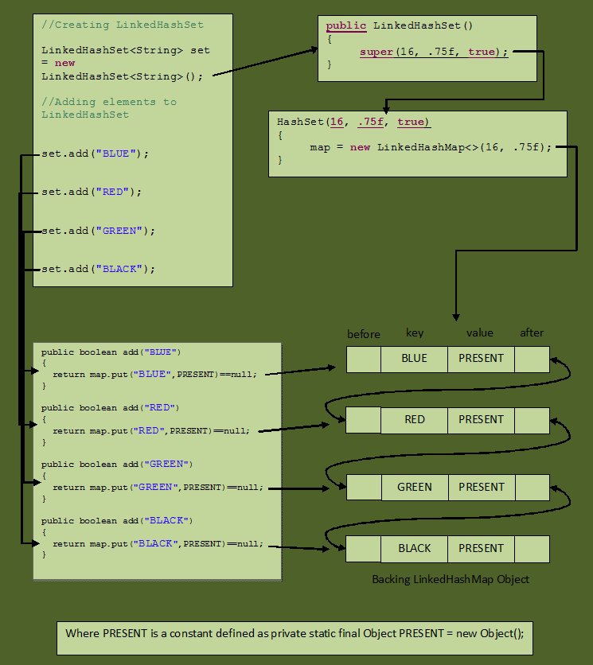

TreeSet – Internal implementation
- Underlying D.S is Red-Black Tree
- Duplicate Objects are Not Allowed
- Insertion order Not Preserved but we can sort elements
- Heterogeneous Objects are Not Allowed , if try it throws ClassCastException at Runtime
- Null Insertion allowed(Only once)
- TreeSet implements Serializable & Clonable but not RandomAccess
- All objects are inserted based on some sorting order either default or customized sorting order

Constructors
TreeSet h = new TreeSet () //Default. SortingOrder
Creates an Empty TreeSet Object, all the elements inserted according to Default Natural SortingOrder
TreeSet h = new TreeSet (Comparator c) //Customized. SortingOrder
Creates an Empty TreeSet Object, all the elements inserted according to Customized SortingOrder
TreeSet h = new TreeSet (Collection c)
TreeSet h = new TreeSet (SortedSet s)
Implementation
TreeSet is like HashSet which contains the unique elements only but in a sorted manner.
TreeSet uses TreeMap internally to store its elements.
public class TreeSet<E> extends AbstractSetimplements NavigableSet,Cloneable, Serializable
{

private static final Object PRESENT = new Object();

public TreeSet() {
this(new TreeMap<E, Object>());
}

public boolean add(E e) {
return map.put(e, PRESENT) == null;
}
}

Queue
- The Queue is used to insert elements at the end of the queue and removes from the beginning of the queue. It follows FIFO concept.
- LinkedList, PriorityQueue are the most frequently used implementations.
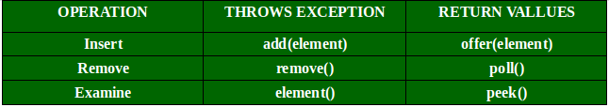

PriorityQueue – Internal implementation
It is known that a queue follows First-In-First-Out algorithm, but sometimes the elements of the queue are needed to be processed according to the priority, that’s when the PriorityQueue comes into play.
- The PriorityQueue is based on the priority heap.
- The PriorityQueue class provides the facility of using queue. But it does not orders the elements in FIFO manner.
- The elements of the priority queue are ordered according to the natural ordering, or by a Comparator provided at queue construction time, depending on which constructor is used.
- PriorityQueue doesn’t permit NULL pointers.
- We can’t create PriorityQueue of Objects that are non-comparable. (String and Wrapper classes are Comparable by default)
- Head of the Queue is the least item in the order.
- PriorityQueue is not synchronized. PriorityBlockingQueue is the thread-safe counterpart of PriorityQueue
- PriorityQueue is unbounded and it grows dynamically based on the number of elements in the Queue. It has internal capacity at any given time and it is increased as the elements are added. The policy for this internal capacity and increment is not specified or standardized
Constructors of PriorityQueue class
- PriorityQueue(): Creates with the default capacity (11) &natural ordering.
- PriorityQueue(int initialCapacity): specified initial capacity & natural ordering.
- PriorityQueue(int initialCapacity, Comparator comparator
- PriorityQueue(PriorityQueue c): Creates a PriorityQueue containing the elements in the specified priority queue.
- PriorityQueue(SortedSet c): Creates a PriorityQueue containing the elements in the specified sorted set.
Internal implementation
Priority queue represented as a balanced binary heap: the two children of queue[n] are queue[2*n+1] and queue[2*(n+1)]. The priority queue is ordered by comparator, or by the elements' natural ordering, if comparator is null: For each node n in the heap and each descendant d of n, n <= d. The element with the lowest value is in queue[0], assuming the queue is nonempty.
private static final int DEFAULT_INITIAL_CAPACITY = 11;
transient Object[] queue;

If array Reaches maximim capacity
queue = Arrays.copyOf(queue, newCapacity);

Establishes the heap invariant (described above) in the entire tree, assuming nothing about the order of the elements prior to the call.
@SuppressWarnings("unchecked")
private void heapify() {
for (int i = (size >>> 1) - 1; i >= 0; i--)
siftDown(i, (E) queue[i]);
}
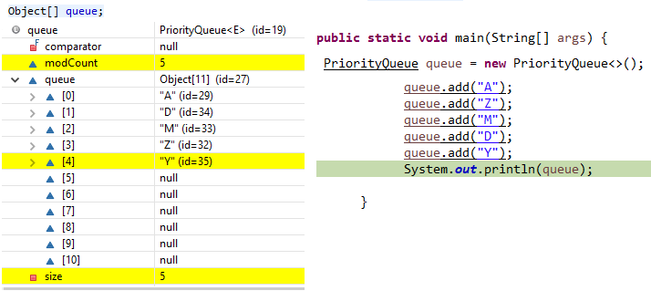

Deque
The Deque is related to the double-ended queue that supports addition or removal of elements from either end of the data structure, it can be used as a queue (first-in-first-out/FIFO) or as a stack (last-in-first-out/LIFO).
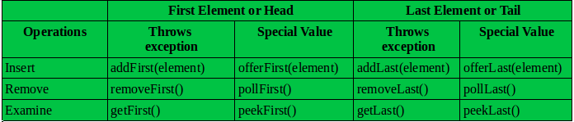

ArrayDeque – Internal implementation
The ArrayDeque class provides the facility of using deque and resizable-array. It inherits AbstractCollection class and implements the Deque interface.
The important points about ArrayDeque class are:
- Unlike Queue, we can add or remove elements from both sides.
- Null elements are not allowed in the ArrayDeque.
- ArrayDeque is not thread safe, in the absence of external synchronization.
- ArrayDeque has no capacity restrictions.
- ArrayDeque is faster than LinkedList and Stack.

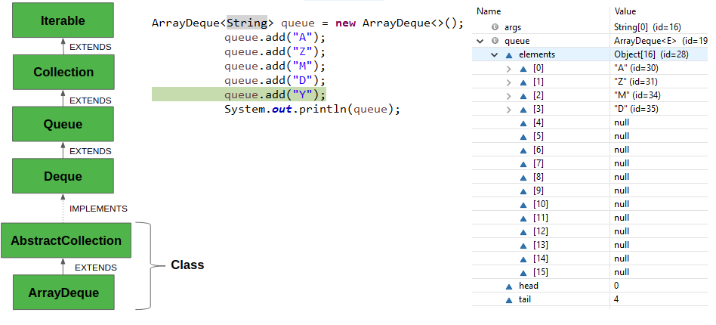

Threads

Concurrent API

Java.util.concurrent API
java.util.concurrent.locks.Lock interface is used to as a thread synchronization mechanism similar to synchronized blocks
There are few differences between the use of synchronized block and using Lock API’s:

A synchronized block is fully contained within a method – we can have Lock API’s lock() and unlock() operation in separate methods
A synchronized block does not support the fairness, any thread can acquire the lock ones released, no preference can be specified. We can achieve fairness within the Lock APIs by specifying the fairness property. It makes sure that longest waiting thread is given access to lock
A thread gets blocked if it can’t get an access to the synchronized block. The Lock API provides tryLock() method. The thread acquires lock only if it’s available and not held by any other thread. This reduces blocking time of thread waiting for the lock
A thread which is in “waiting” state to acquire the access to synchronized block, can’t be interrupted. The Lock API provides a method lockInterruptibly() which can be used to interrupt the thread when it is waiting for the lock

Let’s take a look at the methods in the Lock interface:
- void lock() – acquire the lock if it’s available; if the lock is not available a thread gets blocked until the lock is released
- void lockInterruptibly() – this is similar to the lock(), but it allows the blocked thread to be interrupted and resume the execution through a thrown java.lang.InterruptedException
- boolean tryLock() – this is a non-blocking version of lock() method; it attempts to acquire the lock immediately, return true if locking succeeds
- boolean tryLock(long timeout, TimeUnit timeUnit) – this is similar to tryLock(), except it waits up the given timeout before giving up trying to acquire the Lock
- void unlock() – unlocks the Lock instance
Lock lock = ...;
lock.lock();
try {
// access to the shared resource
} finally {
lock.unlock();
}

In addition to Lock interface, we have a ReadWriteLock interface which maintains a pair of locks, one for read-only operations, and one for the write operation.
- Lock readLock() – returns the lock that’s used for reading
- Lock writeLock() – returns the lock that’s used for writing
ReentrantLock implememnts Lock
1.lock on a resource more than once
ReentrantLock allow threads to enter into lock on a resource more than once. When the thread first enters into lock, a hold count is set to one. Before unlocking the thread can re-enter into lock again and every time hold count is incremented by one. For every unlock request, hold count is decremented by one and when hold count is 0, the resource is unlocked
2.offer a fairness parameter
after a thread unlocks the resource, the lock would go to the thread which has been waiting for the longest time. This fairness mode is set up by passing true to the constructor of the lock.
getHoldCount(): This method returns the count of the number of locks held on the resource
isHeldByCurrentThread(): This method returns true if the lock on the resource is held by the current thread.
ExecutorService Framework
ExecutorService is a framework provided by the JDK which simplifies the execution of tasks in asynchronous mode. Generally speaking, ExecutorService automatically provides a pool of threads and API for assigning tasks to it.
1.Instantiating ExecutorService
Factory Methods of the Executors Class, is the easiest way to create ExecutorService is to use one of the factory methods of the Executors class. following line of code will create a thread-pool with 10 threads:
ExecutorService executor = Executors.newFixedThreadPool(10);
2.Assigning Tasks to the ExecutorService
ExecutorService can execute Runnable and Callable tasks.
Runnable runnableTask = () -> {
try {
TimeUnit.MILLISECONDS.sleep(300);
} catch (InterruptedException e) {
e.printStackTrace();
}
};

Callable<String> callableTask = () -> {
TimeUnit.MILLISECONDS.sleep(300);
return "Task's execution";
};
Tasks can be assigned to the ExecutorService using several methods, including execute(), which is inherited from the Executor interface, and also submit(), invokeAny(), invokeAll().
1.execute() method is void, and it doesn’t return anything.
executorService.execute(runnableTask);

2.submit() submits a Callable/Runnable task to an ExecutorService and returns a result of type Future.
Future<String> future = executorService.submit(callableTask);

3.invokeAny(Collection) assigns a collection of tasks to an ExecutorService& returns the result of a successful execution of one task (if there was a successful execution).
String result = executorService.invokeAny(callableTasks);

4.invokeAll(Collection) assigns a collection of tasks to an ExecutorService,returns the result of all task executions in the form of a list of objects of type Future.
List<Future<String>> futures = executorService.invokeAll(callableTasks);

3.Shutting Down an ExecutorService
1.shutdown() method doesn’t cause an immediate destruction of the ExecutorService. It will make the ExecutorService stop accepting new tasks & shutdown after all running threads finish their work.
executorService.shutdown();

2.shutdownNow() method tries to destroy the ExecutorService immediately, but it doesn’t guarantee that all the running threads will be stopped at the same time. This method returns a list of tasks which are waiting to be processed. It is up to the developer to decide what to do with these tasks.
List<Runnable> notExecutedTasks = executorService.shutDownNow();

Future Interface
The submit() and invokeAll() methods return an object or a collection of objects of type Future, which allows us to get the result of a task’s execution or to check the task’s status (is it running or executed).
Future<String> future = executorService.submit(callableTask);
String result = null;
try {
result = future.get();
} catch (InterruptedException | ExecutionException e) {
e.printStackTrace();
}
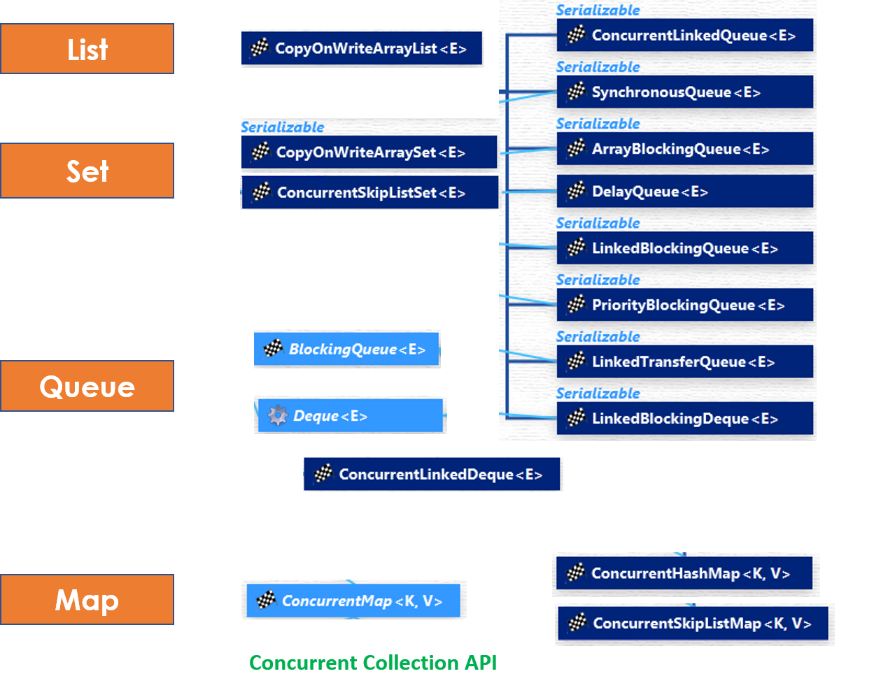

List – CopyOnWriteArrayList
- CopyOnWriteArrayList is a thread-safe variant of java.util.ArrayList.All mutative operations (add, set, and so on) are implemented by making a fresh copy of the underlying array.
- As the name indicates, CopyOnWriteArrayList creates a Cloned copy of underlying ArrayList, for every update operation at certain point both will synchronized automatically which is takes care by JVM. So, there is no effect for threads which are performing read operation.
- It is costly to use because for every update operation a cloned copy will be created. Hence CopyOnWriteArrayList is the best choice if our frequent operation is read operation.
- The underlined data structure is grow-able array &
- It is thread-safe version of ArrayList.
Methods Summary:
- public boolean addIfAbsent(Object obj)
- public int addAllAbsent(Collection C)
Iterator of CopyOnWriteArrayList is fail-safe and doesn't throw ConcurrentModificationException even if underlying CopyOnWriteArrayList is modified once Iteration begins because Iterator is operating on a separate copy of ArrayList. Consequently, all the updates made on CopyOnWriteArrayList is not available to Iterator (see Java Fundamentals: Collections).
The between CopyOnWriteArrayList vs ArrayList is that Iterator of former doesn't support remove operation while Iterator of later supports remove() operation.
public class CopyOnWriteArrayListExample {
public static void main(String args[]) {

CopyOnWriteArrayList<String> list = new CopyOnWriteArrayList<String>();
list.add("Java");
list.add("J2EE");
list.add("Collection");

//add, remove operator is not supported by CopyOnWriteArrayList iterator
Iterator<String> itr = list.iterator();
while(itr.hasNext()){
System.out.printf("Read from CopyOnWriteArrayList : %s %n", itr.next());
// itr.remove(); //not supported in CopyOnWriteArrayList in Java
list.add("New");
}
System.out.println(list);
}
}

Set – CopyOnWriteArraySet, ConcurrentSkipListSet

CopyOnWriteArraySet
- CopyOnWriteArraySet is a Set that uses an internal CopyOnWriteArrayList for all of its operations.
- One of the most important thing to know about CopyOnWriteArraySet is that it is backed by CopyOnWriteArrayList, which means it also share all basic properties of CopyOnWriteArrayList.
- Another important thing to remember is that Iterators of this collection class doesn't support remove() operation, trying to remove an element while iterating will result in UnSupportedOperationException.
- its a little brother of CopyOnWriteArrayList, so if you understand one of them, you can use others. Only difference being these two are one is List and other is Set, but that brings all difference between Set and List in Java. For example, List is ordered, allows duplicate while Set is unordered, but doesn't allow duplicate.

ConcurrentSkipListSet
- ConcurrentSkipListSet maintains the behavior same as TreeSet.
- Since ConcurrentSkipListSet implements NavigableSet in Java, it is a sorted set just like TreeSet with added feature of being concurrent. Which essentially means it is a sorted data structure which can be used by multiple threads where as TreeSet is not thread safe.
- The elements of the ConcurrentSkipListSet are kept sorted according to their natural ordering, or by a Comparator provided at set creation time, depending on which constructor is used.
- ConcurrentSkipListSet provides a constructor that takes a comparator as a parameter.
- ConcurrentSkipListSet(Comparator<? super E> comparator) - Constructs a new, empty set that orders its elements according to the specified comparator.
- ConcurrentSkipListSet implementation provides expected average log(n) time cost for the contains, add, and remove operations and their variants. Insertion, removal, and access operations safely execute concurrently by multiple threads.

Map – ConcurrentMap ConcurrentHashMap, ConcurrentSkipListMap

ConcurrentMap:
ConcurrentMap is an interface, which is introduced in JDK 1.5 represents a Map which is capable of handling concurrent access
It extends map interface in Java. Below are specific methods of ConcurrentMap interface:
- Object putIfAbsent(K key, V value):If the specified key is not already associated with a value, associate it with the given value.
- boolean remove(Object key, Object value):Removes the entry for a key only if currently mapped to a given value.
- boolean replace(K key, V oldValue, V newValue):Replaces the entry for a key only if currently mapped to a given value

ConcurrentHashMap
- ConcurrentHashMap only locks a portion of the collection on update.
- ConcurrentHashMap is better than Hashtable and synchronized Map.
- ConcurrentHashMap is failsafe does not throws ConcurrentModificationException.
- null is not allowed as a key or value in ConcurrentHashMap.
- Level of concurrency can be chosen by the programmer on a ConcurrentHashMap while initializing it.
ConcurrentHashMap(int initialCapacity, float loadFactor, int concurrencyLevel)
By default ConcurrentHashMap allows 16 number of concurrent threads. We can change this number using the concurrencyLevl argument.
ConcurrentSkipListMap
Since ConcurrentSkipListMap implements ConcurrentNavigableMap, it is a sorted map just likeTreeMap (Which also implements NavigableMap interface).
ConcurrentSkipListMap is sorted according to the natural ordering of its keys, or by a Comparatorprovided at map creation time, depending on which constructor is used.
ConcurrentSkipListMap in Java provides four constructors, out of those 2 relevant ones are -
- ConcurrentSkipListMap() - Constructs a new, empty map, sorted according to the natural ordering of the keys.
- ConcurrentSkipListMap(Comparator<? super K> comparator) - Constructs a new, empty map, sorted according to the specified comparator.
ConcurrentSkipListMap class in Java implements a concurrent variant of SkipLists data structure providing expected average log(n) time cost for the containsKey, get, put and remove operations and their variants. Insertion, removal, update, and access operations safely execute concurrently by multiple threads.
All Map.Entry pairs returned by methods in ConcurrentSkipListMap class and its views represent snapshots of mappings at the time they were produced.

Queue – BlockingQueue PriorityBlockingQueue ,ArrayBlockingQueue,
BlockingQueue
A BlockingQueue is typically used to have on thread produce objects, which another thread consumes. Here is a diagram that illustrates this principle:
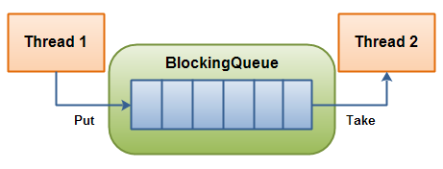
 | Throws Exception | Special Value | Blocks | Times Out
Insert | add(o) | offer(o) | put(o) | offer(o, timeout, timeunit)
Remove | remove(o) | poll() | take() | poll(timeout, timeunit)
Examine | element() | peek()
- BlockingQueue in Java doesn't allow null elements, various implementations like ArrayBlockingQueue, LinkedBlockingQueue throws NullPointerException when you try to add null on queue
- two types of BlockingQueue:
  - Bounded queue – with maximal capacity defined
BlockingQueue<String> blockingQueue = new LinkedBlockingDeque<>();
  - UnBounded queue –no maximum capacity, can grow almost indefinitely
BlockingQueue<String> blockingQueue = new LinkedBlockingDeque<>(10);

Producer-Consumer Example
BlockingQueue provides a put() method to store the element and take() method to retrieve the element. Both are blocking method, which means put() will block if the queue has reached its capacity and there is no place to add a new element.
Similarly, take() method will block if blocking queue is empty. So, you can see that critical requirement of the producer-consumer pattern is met right there, you don't need to put any thread synchronization code.
class Producer extends Thread {
private BlockingQueue<Integer> sharedQueue;
public Producer(BlockingQueue<Integer> aQueue) {
super("PRODUCER");
this.sharedQueue = aQueue;
}
public void run() { // no synchronization needed
for (int i = 0; i < 10; i++) {
try {
System.out.println(getName() + " produced " + i);
sharedQueue.put(i);
Thread.sleep(200);
// if we remove sleep, put will execute 10 times, then take will execute
} catch (InterruptedException e) {
e.printStackTrace();
}
}
}
}
class Consumer extends Thread {
private BlockingQueue<Integer> sharedQueue;

public Consumer(BlockingQueue<Integer> aQueue) {
super("CONSUMER");
this.sharedQueue = aQueue;
}

public void run() {
try {
while (true) {
Integer item = sharedQueue.take();
System.out.println(getName() + " consumed " + item);
}
} catch (InterruptedException e) {
e.printStackTrace();
}
}
}

public class BlockingQueueDemo {
public static void main(String[] args) {
BlockingQueue<Integer> sharedQ = new LinkedBlockingQueue<Integer>();
Producer p = new Producer(sharedQ);
Consumer c = new Consumer(sharedQ);
p.start();
c.start();
}
}
- ArrayBlockingQueue – a blocking queue class based on bounded Java Array. Once instantiated, cannot be resized.
- PriorityBlockingQueue – a priority queue based blocking queue. It is an unbounded concurrent collection.
- LinkedBlockingQueue – an optionally bounded Java concurrent collection. Orders elements based on FIFO order.

Deque - ConcurrentLinkedDeque
ConcurrentLinkedDeque in Java is an unbounded thread-safe Deque which stores its elements as linked nodes. Since it implements deque interface ConcurrentLinkedDeque supports element insertion and removal at both ends. You will find methods like addFirst(), addLast(), getFirst(), getLast(), removeFirst(), removeLast() to facilitate operations at both ends.
Usage of ConcurrentLinkedDeque
A ConcurrentLinkedDeque is an appropriate choice when many threads will share access to a common collection as concurrent insertion, removal, and access operations execute safely across multiple threads.
Note that it doesn't block operations as done in the implementation of BlockingDequeue interfacelike LinkedBlockingDeque. So there are no putFirst(), takeFirst() or putLast(), takeLast() methods which will wait if required.

Java.util.Arrays
This class contains various methods for manipulating arrays (such as sorting and searching). This class also contains a static factory that allows arrays to be viewed as lists.
Arrays to list
Sorting & Searching
Copying & filling
- public static String toString(int[] a) The string representation consists of a list of the array’s elements, enclosed in square brackets (“[]”).
- public static List asList(T… a) - This method returns a fixed-size list backed by the specified array. some ladding or removing elements from the list aren’t allowed on the wrapper, , you can only read or overwrite the elements
- public static void sort(int[] a) – Sorts the specified array into ascending numerical order.
- public static void sort(int[] a, int fromIndex, int toIndex) If we wish to sort a specified range of the array into ascending order.
- public static int binarySearch(int[] a, int key) Returns an int value for the index of the specified key in the specified array. Returns a negative number if the specified key is not found in the array.
- public static int[] copyOf(int[] original, int newLength) Copies the specified array and length. It truncates the array if provided length is smaller and pads if provided .
- public static int[] copyOfRange(int[] original, int from, int to) Copies the specified range of the specified array into a new array
- public static void fill(int[] a, int val) Fills all elements of the specified array with the specified value.
- public static void fill(int[] a, int fromIndex, int toIndex, int val) – Fills elements of the specified array with the specified value from the fromIndex element, but not including the toIndex element.
- static boolean equals(Object[] a, Object[] a2) - This method returns true if the two specified arrays of Objects are equal to one another.
- static int hashCode(Object[] a)- This method returns a hash code based on the contents of the specified array.

java.util.Collections class
This class consists exclusively of static methods that operate on or return collections. It contains polymorphic algorithms that operate on collections, "wrappers", which return a new collection backed by a specified collection, and a few other odds and ends.
The methods of this class all throw a NullPointerException if the collections or class objects provided to them are null.
- List<String> list = List.of("foo", "bar", "baz");
- Set<String> set = Set.of("foo", "bar", "baz");
- Map<String, String> map = Map.of("foo", "a", "bar", "b", "baz", "c");
Map<String, String> map = Map.ofEntries(
new AbstractMap.SimpleEntry<>("foo", "a"),
new AbstractMap.SimpleEntry<>("bar", "b"),
new AbstractMap.SimpleEntry<>("baz", "c"));
- static void sort(List list1): Sorts the list list1 into ascending order according to the natural sequence (a before b or 1 before 2) of the elements.
- static int binarySearch(List list1, Object obj1): Searches the obj1 in the list list1. Returns the index number of the element obj1. Before applying this method, the elements must be sorted earlier with sort() method
- static Collection synchronizedCollection(Collection col1): Returns a synchronized version of collection col1. It is used for thread-safe operations. The synchronized version can be used safely in a multithreaded environment. Methods like synchronizedSet(), synchronizedSortedSet(), synchronizedList(), synchronizedMap() and synchronizedSortedMap()
- static void reverse(List list1): Existing order of the elements in the list list1 are reversed.
- static void shuffle(List list1): Shuffles the existing elements of list1 randomly. For repeated execution of the method, elements with different order are obtained.
- static void swap(List list1, int index1, int index2): List list1 elements at index numbers index1 and index2 are swapped.
- static void fill(List list1, Object obj1): Replaces all the elements of list1 with obj1. Earlier elements are lost. This method is used to fill all the elements with the same values.
- static void copy(List destination1, List source1): Copies all the elements of List source1into the destination1 list. It is like arraycopy() method.
- static Object min(Collection col1): Returns the element with the minimum value
- static Object max(Collection col1): Returns the element with the maximum value
- static void rotate(List list1, int dist1): Rotates the elements in the list list1 by the specified distance dist1.
- static boolean replaceAll(List list1, Object oldObj, Object newObj): Replaces the old element oldObj with the new element newObj in the list list1 (all the occurrences). Returns true when the operation is successful (when the oldObj exists).
- static Collection unmodifiableCollection(Collection col1): Returns an unmodifiable (read-only) version of col1. Any methods like add() or remove(), if applied throws UnsupportedOperationException. To use with map, list and set, also exists the methods like unmodifiableMap(), unmodifiableSortedMap(), unmodifiableSet(), unmodifiableSortedSet(), unmodifiableList() etc. exist.
- static int frequency(Collection col1, Object obj1): Checks how many times obj1 exists in collection col1, returns as an integer value.
- static boolean disjoint(Collection col1, Collection col2): Returns true if the collection classes col1 and col2 do not have any common elements. Introduced with JDK 1.5.
- static boolean addAll(Collection col1, Object obj1): Here, obj1 can be a single element or an array. Adds obj1 to the collection col1.

CountDownLatch Class
A java.util.concurrent.CountDownLatch is a concurrency construct that allows one or more threads to wait for a given set of operations to complete.
CountDownLatch works by having a counter initialized with number of threads, which is decremented each time a thread complete its execution. When count reaches to zero, it means all threads have completed their execution, and thread waiting on latch resume the execution.
Essentially, by using a CountDownLatch we can cause a thread to block until other threads have completed a given task
Thread Z should start after completion A,B,C Thraeds execution.

The CountDownLatch class has following basic elements :
– An initialization(CountDownLatch(int num)) count that determines how many events it will wait for
– An await() method called by Threads that wait for the completion of the events
– The countdown() method that is called by the events when they finish execution
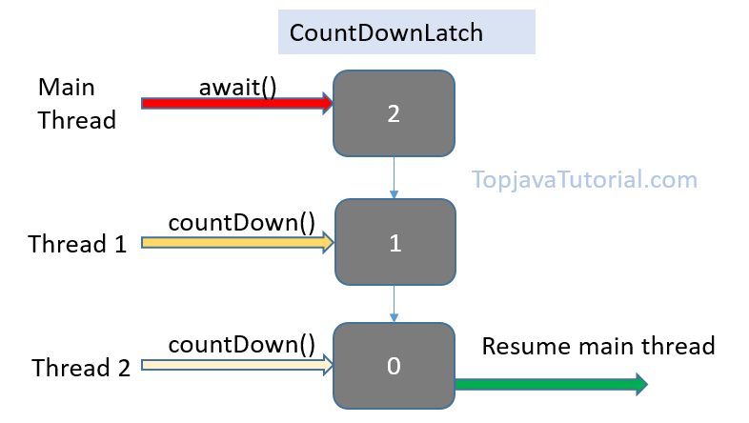
// A class to represent threads for which // the main thread waits.
class Worker extends Thread
{
private int delay;
private CountDownLatch latch;
public Worker(int delay, CountDownLatch latch, String name)
{
super(name);
this.delay = delay;
this.latch = latch;
}

public void run()
{
try
{
Thread.sleep(delay);
latch.countDown();
System.out.println(Thread.currentThread().getName() + " finished");
}
catch (InterruptedException e)
{
e.printStackTrace();
}
}
}
public class CountDownLatchDemo
{
public static void main(String args[]) throws InterruptedException
{
// Let us create task that is going to wait for four threads before it starts
CountDownLatch latch = new CountDownLatch(4);

// Let us create four worker threads and start them.
Worker first = new Worker(1000, latch, "WORKER-1");
Worker second = new Worker(2000, latch, "WORKER-2");
Worker third = new Worker(3000, latch, "WORKER-3");
Worker fourth = new Worker(4000, latch, "WORKER-4");
first.start();
second.start();
third.start();
fourth.start();

// The main task waits for four threads
latch.await();

// Main thread has started
System.out.println(Thread.currentThread().getName() +" has finished");
}
}

Output:

WORKER-1 finished
WORKER-2 finished
WORKER-3 finished
WORKER-4 finished
main has finished

CyclicBarrier Class
CyclicBarrier can be used when a set of two or more threads must wait at some point until all threads have reached that point.
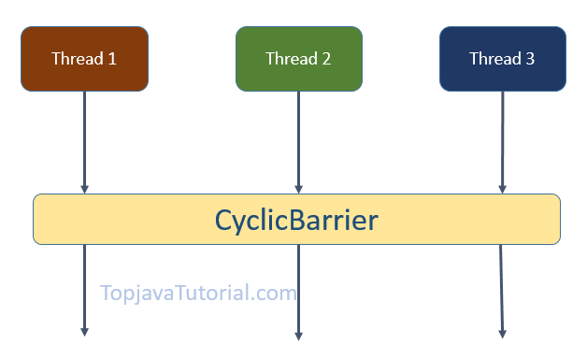
CyclicBarrier(int numberOfThreads) :This creates a new CyclicBarrier that waits until numberOfThreads reach a common barrier point.
await() method : The threads call await() to wait at the barrier point until the specified number is reached.
CyclicBarrier Example
In this example, we create a cyclic barrier with count 3. We then create 3 threads that must wait for each other until all of them reach the barrier point before proceeding with execution

class MyThread implements Runnable {

CyclicBarrier cb;
String name;

MyThread(CyclicBarrier cb, String name) {
this.name = name;
this.cb = cb;
new Thread(this).start();
}

@Override
public void run() {
try {
System.out.println(name + " waiting");
cb.await();
} catch (Exception e) {
e.printStackTrace();
}
System.out.println(name + " completed");
}

}

class FinalAction implements Runnable {

@Override
public void run() {
System.out.println("All threads reached common point");
}

}
public class Strams {

public static void main(String[] args) {

CyclicBarrier cb = new CyclicBarrier(3, new FinalAction());

MyThread thread1 = new MyThread(cb, "First Thread");
MyThread thread2 = new MyThread(cb, "Second Thread");
MyThread thread3 = new MyThread(cb, "Third Thread");
}
}
Output
-----------
Second Thread waiting
First Thread waiting
Third Thread waiting
All threads reached common point
Third Thread completed
First Thread completed
Second Thread completed

Semaphore
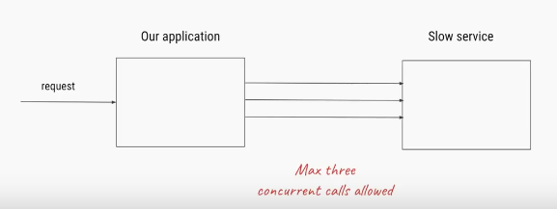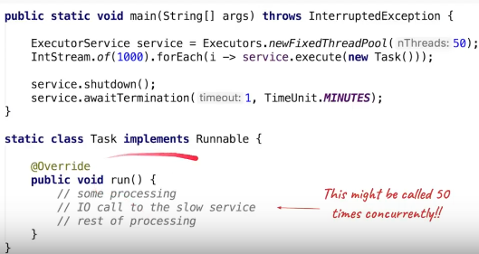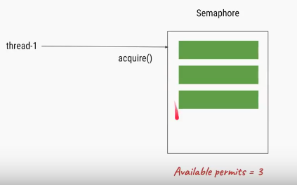
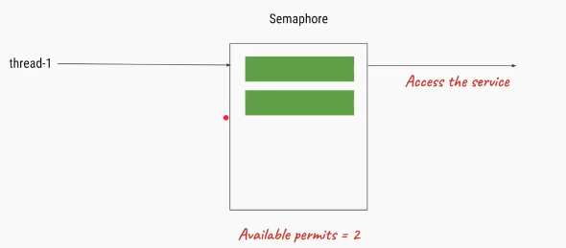
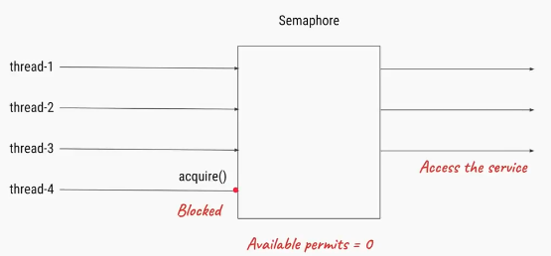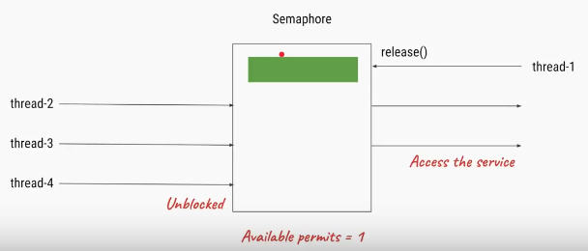

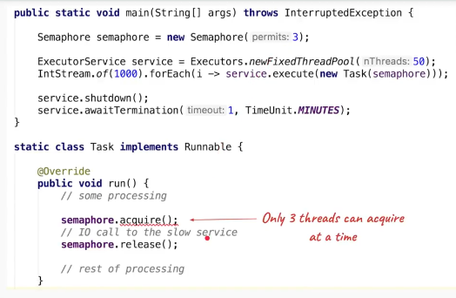
a semaphore maintains a set of permits. Each acquire() blocks if necessary until a permit is available, and then takes it. Each release() adds a permit, potentially releasing a blocking acquirer.
the Semaphore just keeps a count of the number available and acts accordingly. Semaphores are often used to restrict the number of threads than can access some (physical or logical) resource
package coll;

import java.util.concurrent.Semaphore;

public class SemaPhoreTest {

// max 4 people
static Semaphore semaphore = new Semaphore(4);

static class MyATMThread extends Thread {
String name = "";
MyATMThread(String name) {
this.name = name;
}
public void run() {

try {
System.out.println(name + " : acquiring lock...");
semaphore.acquire();
System.out.println(name + " : excuting taskt!");
semaphore.release();

} catch (InterruptedException e) {
e.printStackTrace();
}

}

}

public static void main(String[] args) {

System.out.println("Total available Semaphore permits : " + semaphore.availablePermits());

MyATMThread t1 = new MyATMThread("A");
t1.start();

MyATMThread t2 = new MyATMThread("B");
t2.start();

MyATMThread t3 = new MyATMThread("C");
t3.start();

MyATMThread t4 = new MyATMThread("D");
t4.start();

MyATMThread t5 = new MyATMThread("E");
t5.start();

MyATMThread t6 = new MyATMThread("F");
t6.start();

}
}

Stream API
Java lambda expressions are new in Java 8. Java lambda expressions are Java's first step into functional programming.
Java lambda expressions are commonly used to implement simple event listeners / callbacks, or in functional programming with the Java Streams API

Functional Interfaces
Runnable r = new Runnable(){
@Override
public void run() {
System.out.println("My Runnable");
}};
If you look at the above code, the actual part that is of use is the code inside run() method. Rest all of the code is because of the way java programs are structured.
Java 8 Functional Interfaces and Lambda Expressions help us in writing smaller and cleaner code by removing a lot of boiler-plate code.
- An interface with exactly one abstract method is called Functional Interface.
- @FunctionalInterface annotation is added so that we can mark an interface as functional interface.
- If the interface is annotated with @FunctionalInterface annotation and we try to have more than one abstract method, it throws compiler error.
- The major benefit of java 8 functional interfaces is that we can use lambda expressions to instantiate them and avoid using bulky anonymous class implementation
- Java 8 has defined a lot of functional interfaces in java.util.function package. Some of the useful java 8 functional interfaces are Predicate, Function, Consumer, Supplier,
java.util.function Package:
The java.util.function package in Java 8 contains many builtin functional interfaces like-
1.Predicate: The Predicate interface has an abstract method test() which gives a Boolean value as a result for the specified argument. Its prototype is
public Predicate
{
public boolean test(T t);
}

2.Function: The Function interface has an abstract method apply which takes argument of type T and returns a result of type R. Its prototype is
public interface Function
{
public R apply(T t);
}

3.Consumer Interface: is a functional interface (an interface with a single abstract method). It accepts an input and returns no result.
@FunctionalInterface
public interface Consumer {
void accept(T t);
}
And it contains default method andThen(Consumer<? super T> after)
4.Supplier Interfac: In all scenarios where there is no input to an operation and it is expected to return an output the in-built functional interface Supplier<T> can be used without the need to define a new functional interface every time.
@FunctionalInterface
public interface Supplier<T> {
T get();
}

5.BinaryOperator: The BinaryOperator interface has an abstract method apply which takes two argument and returns a result of same type. Its prototype is
public interface BinaryOperator
{
public T apply(T x, T y);
}

Lambdas
Lambda’s are used To provide the implementation of Functional interface, Less coding.

Lambda Expressions syntax is (argument) -> (body). Now let’s see how we can write above anonymous Runnable using lambda expression.
Runnable r1 = () -> System.out.println("My Runnable");
- The body of a lambda expression can contain zero, one or more statements.
- When there is a single statement curly brackets are not mandatory and the return type of the anonymous function is the same as that of the body expression.
- When there are more than one statements, then these must be enclosed in curly brackets (a code block) and the return type of the anonymous function is the same as the type of the value returned within the code block, or void if nothing is returned
1.Zero parameter:
() -> System.out.println("Zero parameter lambda");
2.One parameter:–
(p) -> System.out.println("One parameter: " + p);
It is not mandatory to use parentheses, if the type of that variable can be inferred from the context
3.Multiple parameters :
(p1, p2) -> System.out.println("Multiple parameters: " + p1 + ", " + p2);
Java Lambda Expression Example: Foreach Loop
Java provides a new method forEach() to iterate the elements. It is defined in Iterable and Stream interface. It is a default method defined in the Iterable interface. Collection classes which extends Iterable interface can use forEach loop to iterate elements.
default void forEach(Consumer<super T>action)
“performs the given action for each element of the Iterable until all elements have been processed or the action throws an exception.”
public class LambdaExpressionExample7{
public static void main(String[] args) {
List<String> list=new ArrayList<String>();
list.add("ankit");
list.add("mayank");
list.add("irfan");
list.add("jai");
list.forEach(
(n)->System.out.println(n)
);
}
}
This code will print every element of the list. You can even replace lambda expression with method reference because we are passing the lambda parameter as it is to the System.out.println() method as
list.forEach(System.out::println);
- forEach() is a terminal operation, which means once calling forEach() method on stream, you cannot call another method. It will result in a runtime exception.
- When you call forEach() on parallel stream, the order of iteration is not guaranteed, but you can ensure that ordering by calling forEachOrdered() method.
- There are two forEach() method in Java 8, one defined inside Iterable and other inside java.util.stream.Stream class. If purpose of forEach() is just iteration then you can directly call it e.g. list.forEach() or set.forEach() but if you want to perform some operations e.g. filter or map then better first get the stream and then perform that operation and finally call forEach() method.
- Use of forEach() results in readable and cleaner code.
Java Lambda Expression Example: Comparator
Collections.sort(list,(p1,p2)->{
return p1.name.compareTo(p2.name);
});
for(Product p:list){
System.out.println(p.id+" "+p.name+" "+p.price);
}

Streams
A stream represents a sequence of elements and supports different kind of operations to perform computations upon those elements.
Stream operations are either intermediate or terminal.
- Intermediate operations return a stream so we can chain multiple intermediate operations without using semicolons.
- Terminal operations are either void or return a non-stream result
List<String> myList = Arrays.asList("a1", "a2", "b1", "c2", "c1");

myList
.stream()
.filter(s -> s.startsWith("c"))
.map(String::toUpperCase)
.sorted()
.forEach(System.out::println);
In the above example filter, map and sorted are intermediate operations whereas forEach is a terminal operation
Streams can be created from various data sources, especially collections. Lists and Sets support new methods stream() and parallelStream() to either create a sequential or a parallel stream.
Parallel streams are capable of operating on multiple threads
The features of Java stream are
- A stream is not a data structure instead it takes input from the Collections, Arrays or I/O channels.
- Streams don’t change the original data structure, they only provide the result as per the pipelined methods.
- Each intermediate operation is lazily executed and returns a stream as a result, hence various intermediate operations can be pipelined. Terminal operations mark the end of the stream and return the result.
1.Obtaining a Stream
//1.Stream of Collection
Collection<String> collection = Arrays.asList("a", "b", "c");
Stream<String> streamOfCollection = collection.stream();

//2.Stream of Arrays
Stream<String> streamOfArray = Stream.of("a", "b", "c");
Stream Operations : Intermediate
Operation | Contents
filter(Predicate<T>) | The elements of the stream matching the predicate
map(Function<T, U>) | The result of applying the provided function to the elements of the stream
flatMap(Function<T, Stream<U>> | The elements of the streams resulting from applying the provided stream-bearing function to the elements of the stream
distinct() | The elements of the stream, with duplicates removed
sorted() | The elements of the stream, sorted in natural order
Sorted(Comparator<T>) | The elements of the stream, sorted by the provided comparator
limit(long) | The elements of the stream, truncated to the provided length
skip(long) | The elements of the stream, discarding the first N elements
takeWhile(Predicate<T>) | (Java 9 only) The elements of the stream, truncated at the first element for which the provided predicate is not true
dropWhile(Predicate<T>) | (Java 9 only) The elements of the stream, discarding the initial segment of elements for which the provided predicate is true

Terminal Operations
forEach(Consumer<T> action) | Apply the provided action to each element of the stream.
toArray() | Create an array from the elements of the stream.
reduce(...) | Aggregate the elements of the stream into a summary value.
collect(...) | Aggregate the elements of the stream into a summary result container.
min(Comparator<T>) | Return the minimal element of the stream according to the comparator.
max(Comparator<T>) | Return the maximal element of the stream according to the comparator.
count() | Return the size of the stream.
{any,all,none}Match(Predicate<T>) | Return whether any/all/none of the elements of the stream match the provided predicate.
findFirst() | Return the first element of the stream, if present.
findAny() | Return any element of the stream, if present.

Finally most commonly used Operations
Intermediate Operations:
map: The map method is used to map the items in the collection to other objects according to the Predicate passed as argument.
List number = Arrays.asList(2,3,4,5);
List square = number.stream().map(x->x*x).collect(Collectors.toList());
filter: The filter method is used to select elements as per the Predicate passed as argument.
List names = Arrays.asList("Reflection","Collection","Stream");
List result = names.stream().filter(s->s.startsWith("S")).collect(Collectors.toList());
sorted: The sorted method is used to sort the stream.
List names = Arrays.asList("Reflection","Collection","Stream");
List result = names.stream().sorted().collect(Collectors.toList());
Terminal Operations:
collect: The collect method is used to return the result of the intermediate operations performed on the stream.
List number = Arrays.asList(2,3,4,5,3);
Set square = number.stream().map(x->x*x).collect(Collectors.toSet());
forEach: The forEach method is used to iterate through every element of the stream.
List number = Arrays.asList(2,3,4,5);
number.stream().map(x->x*x).forEach(y->System.out.println(y));
reduce: The reduce method is used to reduce the elements of a stream to a single value.
The reduce method takes a BinaryOperator as a parameter.
List number = Arrays.asList(2,3,4,5);
int even = number.stream().filter(x->x%2==0).reduce(0,(ans,i)-> ans+i);
Example
class Product{
int id;
String name;
float price;
public Product(int id, String name, float price) {
this.id = id;
this.name = name;
this.price = price;
}
}

public class Strams {
public static void main(String[] args) {

List<Product> productsList = new ArrayList<Product>();
//Adding Products
productsList.add(new Product(1,"HP Laptop",25000f));
productsList.add(new Product(2,"Dell Laptop",30000f));
productsList.add(new Product(3,"Lenevo Laptop",28000f));
productsList.add(new Product(4,"Sony Laptop",28000f));
productsList.add(new Product(5,"Apple Laptop",90000f));

List<Float> productPriceList2 =productsList.stream()
.filter(p -> p.price > 30000)// filtering data
.map(p->p.price) // fetching price
.collect(Collectors.toList()); // collecting as list
System.out.println(productPriceList2); //[90000.0]

// This is more compact approach for filtering data
productsList.stream()
.filter(product -> product.price == 30000)
.forEach(product -> System.out.println(product.name)); // Dell Laptop

// count number of products based on the filter
long count = productsList.stream()
.filter(product->product.price<30000)
.count();
System.out.println(count); //3

// Converting product List into Set
Set<Float> productPriceList = productsList.stream()
.filter(product->product.price < 30000) // filter product on the base of price
.map(product->product.price) //get the price
.collect(Collectors.toSet()); // collect it as Set(remove duplicate elements)
System.out.println(productPriceList); //[25000.0, 28000.0]

}
}
References
- https://www.pearsonfrank.com/blog/java-interview-questions/
- https://javarevisited.blogspot.com/2015/10/133-java-interview-questions-answers-from-last-5-years.html
- http://www.java67.com/2012/09/top-10-tricky-java-interview-questions-answers.html
- https://howtodoinjava.com/java-interview-questions/
- https://www.janbasktraining.com/blog/core-java-interview-questions-answers/
- https://snowdream.github.io/115-Java-Interview-Questions-and-Answers/115-Java-Interview-Questions-and-Answers/en/exception.html
- https://javapapers.com/java/java-concurrent-collections/

